**ASSIGNMENT 7**

* **Table to show the result and operation at each stage of the multiplication.**

|  |  |  |  |  |  |
| --- | --- | --- | --- | --- | --- |
| **STAGE** | **MULTIPLIER** | **FUNCTION** | **C** | **A3 A2 A1 A0** | **Q3 Q2 Q1 Q0** |
| 0 | 0 | Initial values | 0 | 0 0 0 0 | 1 0 0 1 |
| 1 | 1 | Add | 0 | 1 1 0 1 | 1 0 0 1 |
| Shift | 0 | 0 1 1 0 | 1 1 0 0 |
| 2 | 0 | Shift | 0 | 0 0 1 1 | 0 1 1 0 |
| 3 | 0 | Shift | 0 | 0 0 0 1 | 1 0 1 1 |
| 4 | 1 | Add | 0 | 1 1 1 0 | 1 0 1 1 |
| Shift | 0 | 0 1 1 1 | 0 1 0 1 |

**Q : 1 Describe the rules for the use of carry bit in your multiplier.**

**Ans:** Carry bit holds the MOST SIGNIFICANT BIT in 4-bit addition (for example: 01111 + 00011 = **1**0010). D flip-flop is used to store the memory of the carry bit after addition and then shifted to A3. Before the next stage starts, the value of C becomes zero which means D flip-flop ‘resets’.

**INITIAL STAGE**

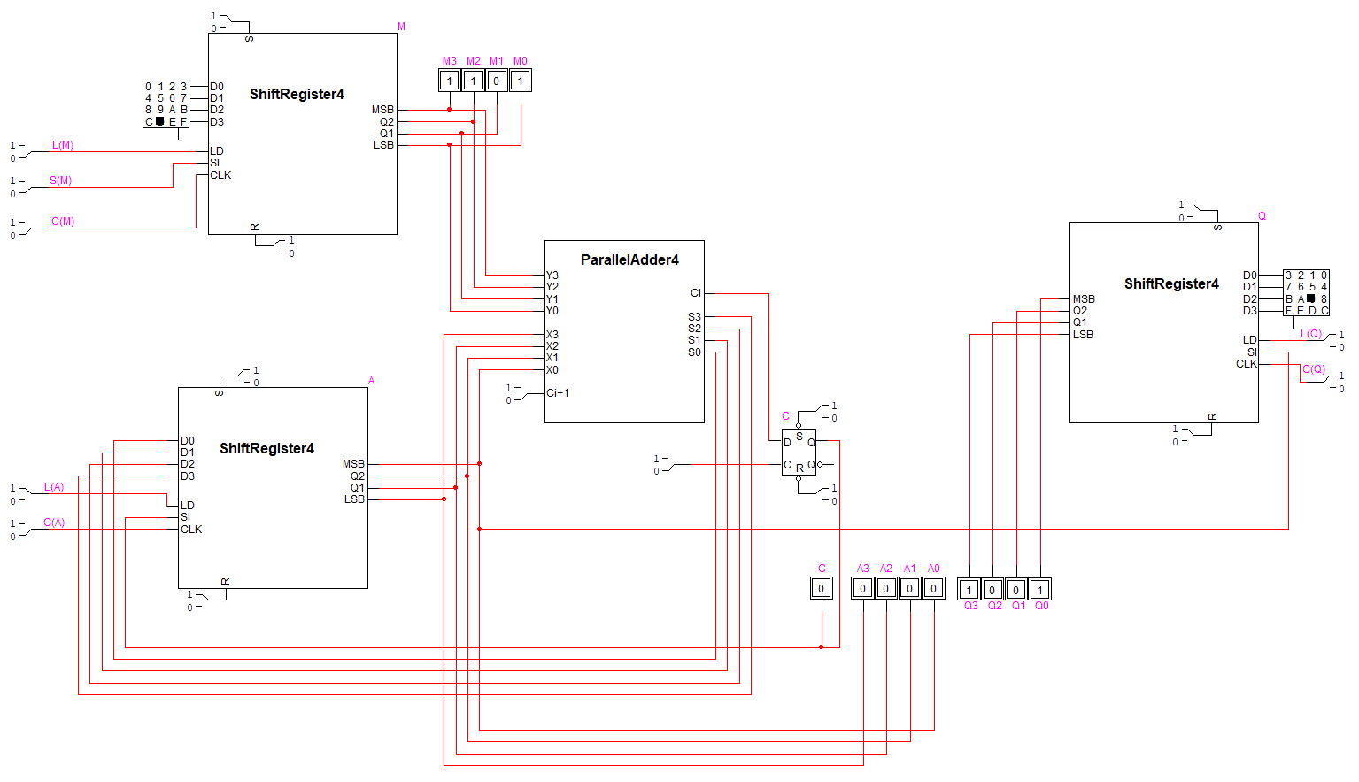

**FINAL STAGE**

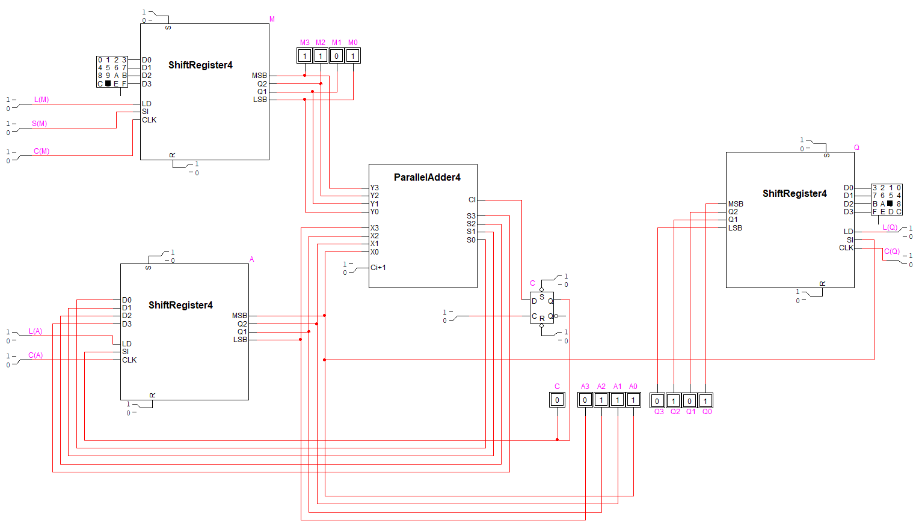

**(ADDITIONAL STAGES) STAGE 2**

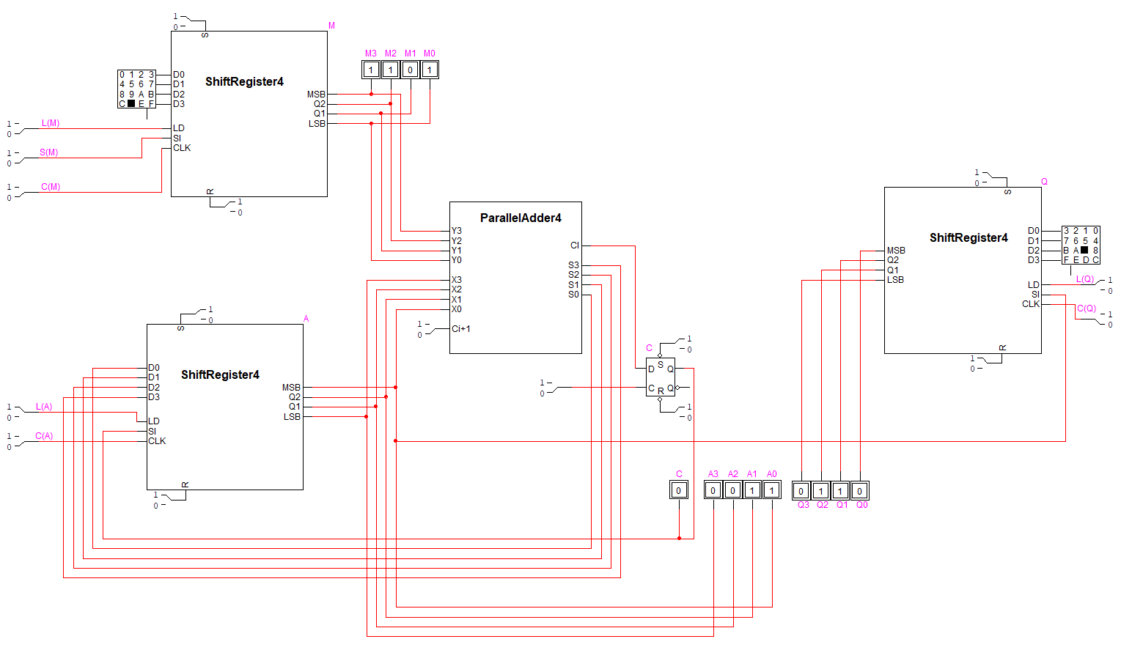

**(ADDITIONAL STAGES) STAGE 3**

